**ASSIGNMENT 1 FRONT SHEET**

|  |  |  |  |
| --- | --- | --- | --- |
| **Qualification** | **BTEC Level 5 HND Diploma in Business** | | |
| **Unit number and title** | **Unit 30: Application Development** | | |
| **Submission date** |  | **Date Received 1st submission** |  |
| **Re-submission Date** |  | **Date Received 2nd submission** |  |
| **Student Name** | Nguyen Van Hoan | **Student ID** | GCS190736 |
| **Class** | GCD0904 | **Assessor name** | Nguyen Van Loi |
| **Student declaration**  I certify that the assignment submission is entirely my own work and I fully understand the consequences of plagiarism. I understand that making a false declaration is a form of malpractice. | | | |
|  |  | **Student’s signature** |  |

**Grading grid**

|  |  |  |  |  |  |
| --- | --- | --- | --- | --- | --- |
| **P1** | **P2** | **P3** | **M1** | **M2** | **D1** |
|  |  |  |  |  |  |

|  |  |  |
| --- | --- | --- |
| **❒ Summative Feedback: ❒ Resubmission Feedback:** | | |
| **Grade:** | **Assessor Signature:** | **Date:** |
| **Internal Verifier’s Comments:** | | |
| **Signature & Date:** | | |

Table of Contents

Software Requirements Specification1

Type chapter title (level 1)4

Type chapter title (level 2)5

Type chapter title (level 3)6

Software Requirements Specification

for

FPT Book Project Application Development

Version <1.0>

Prepared by Nguyen Van Hoan

Group Name: <*place your group name here*>

|  |  |  |
| --- | --- | --- |
| Nguyen Van Hoan | GCS190736 | Hoannvgcs190736@fpt.edu.vn |
| <name> | <student #> | <e-mail> |
| <name> | <student #> | <e-mail> |
| <name> | <student #> | <e-mail> |
| <name> | <student #> | <e-mail> |

|  |  |
| --- | --- |
| Instructor: | Nguyen Van Loi |
| Course: | Application Development |
| Date: |  |

# Contents

Contents v

Revisions vi

1 Introduction (P1) 7

1.1 Document Purpose 7

1.2 Product Scope 7

1.3 Intended Audience and Document Overview 7

1.4 Definitions, Acronyms and Abbreviations 7

1.5 References and Acknowledgments 7

2 Overall Description (P1) 8

2.1 Product Overview 8

2.2 Product Functionality 8

3 Specific Requirements (P1 & M1) 8

3.1 Functional Requirements (P1) 8

3.2 Use Case Model (P1) 9

3.3 Wireflow (P1) 9

4 Technical Design (M1) 11

4.1 Entity Relationship Diagram (ERD) 11

4.2 Class Diagram 11

4.3 Activity Diagram 11

4.4 Gantt Chart 11

5 Risk Assessment (P2) 11

5.1 Risk Assessment 11

*6* Nguyen Van hoan 12

# Revisions

| Version | Primary Author(s) | Description of Version | Date Completed |
| --- | --- | --- | --- |
| Draft Type and Number | Nguyen Van Hoan | Information about the revision. This table does not need to be filled in whenever a document is touched, only when the version is being upgraded. | 12/11/2022 |

# 

# Introduction (P1)

## Document Purpose

The goal of the paper is to provide a detailed description of the functional and non-functional requirements for the creation of the FPT Books Website System, including information on revision and authors. The system administrator, store owners, and end-point users are the document's intended audience. Another audience that can be mentioned is our development team.

## Product Scope

The company FPT wanted to create a new business plan about management or purchasing and selling the book. The FPTBook is a web-based software system created to help bookshop owners manage book sales and purchases by easing and accelerating online book ordering, selection, and purchases for customers and gathering information about those customers and their transactions for store owners. The initiative will be implemented in the retail locations, and both customers and store owners will have access to the website. This website seeks to improve user experience, make business between customers and store owners more convenient, and assist store owners in managing their businesses more effectively.

## Intended Audience and Document Overview

This document is written for three main audiences or readers: administrators, endpoint users, and store owners. We will represent each reader differently through this document, so for a deeper understanding of this report, we recommend that you read it from top to bottom and read each section one by one. General, below are the following parts:

* **Contents:** The contents consist of the headings of each part of the text, it is usually a header and is highlighted and numbered. It helps summarize the layout of the document so that the reader has an overview of the content of the document.
* **Revisions:** The Revision provides information about the process of the document. It is including information about the order, the author's name, the description, and the date of the version. For example, Firstdraft – Nguyen Van Hoan - Introduction finished – December 19th, 2022.
* **Introduction:** The introduction provides the readers or audience have an overview of the project and documents like the objectives, the scope for which it is documented, acronyms and abbreviations, and references.
* **Overall Description:** The overall description provides the readers or audience have an overview of the product that the SRS wrote and its functionalities.
* **Specific Requirements:** The specific requirements provide the functional requirements of the project and the technical depiction, such as the system's wire flow and use case model.
* **Risk Assessment:** The risk assessment is the risk the development team may face in the development phase. examines the effects of various risks on the project's success.

## Definitions, Acronyms and Abbreviations

<Define all the terms necessary to properly interpret the SRS, including acronyms and abbreviations. You may wish to build a separate glossary that spans multiple projects or the entire organization, and just include terms specific to a single project in each SRS.

TO DO: Please provide a list of all abbreviations and acronyms used in this document sorted in alphabetical order.>

## References and Acknowledgments

<List any other documents or Web addresses to which this SRS refers. These may include user interface style guides, contracts, standards, system requirements specifications, use case documents, or a vision and scope document. >

# Overall Description (P1)

## Product Overview

<Describe the context and origin of the product being specified in this SRS. For example, state whether this product is a follow-on member of a product family, a replacement for certain existing systems, or a new, self-contained product. If the SRS defines a component of a larger system, relate the requirements of the larger system to the functionality of this software and identify interfaces between the two. In this part, make sure to include a simple diagram that shows the major components of the overall system, subsystem interconnections, and external interface. In this section it is crucial that you will be creative and provide as much information as possible.

TO DO: Provide at least one paragraph describing product perspective. Provide a general diagram that will illustrate how your product interacts with the environment and in what context it is being used. This is not a formal diagram, but rather something that is used to illustrate the product at a high level.>

## Product Functionality

<Summarize the major functions the product must perform or must let the user perform. Details will be provided in Section 3, so only a high level summary is needed here. These can be at the level given in the project description.>

TO DO:

1. Provide a bulleted list of all the major functions of the system

# Specific Requirements (P1 & M1)

## Functional Requirements (P1)

*< Functional requirements capture the intended behavior of the system. This behavior may be expressed as services, tasks or functions the system is required to perform.*

|  |  |  |  |
| --- | --- | --- | --- |
| **ID** | **AS A** < TYPE OF USER > | **I WANT TO** < PERFORM SOME TASK > | **SO THAT I CAN** < ACHIEVE SOME GOAL > |
| 1 | Project Manager | View a status report from each team member | Ensure the project stays on track. |
| 2 | Employee | Be reminded of upcoming deadlines | Complete my tasks on time. |
| 3 | Director | See the big picture view of department work | Stay in the loop. |
|  |  |  |  |
|  |  |  |  |
|  |  |  |  |

## Use Case Model (P1)

TO DO: Provide a use case diagram that will encapsulate the entire system and all actors.

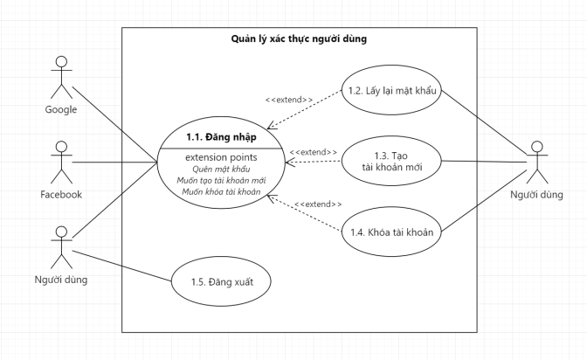

## Wireflow (P1)

<Describe the logical characteristics of each interface between the software product and the users. For your project, you only need to be concerned with the main thermostat (not the mobile app) and can use the graphic from the project description as the basis for your user interface..

TO DO: Provide the graphic for the thermostat user interface and provide a basic description as to how users will interact (e.g. tough screen, menus, etc.).>

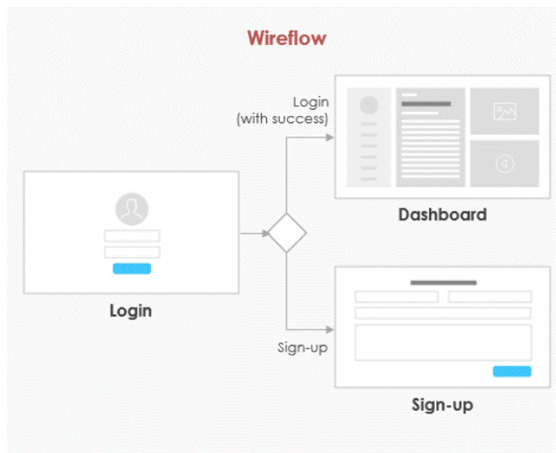

# Technical Design (M1)

## Entity Relationship Diagram (ERD)

## Class Diagram

## Activity Diagram

## Gantt Chart

# Risk Assessment (P2)

## Risk Assessment

| **Identify and list Hazards** | | **List Current Risk Controls** | **Risk Rating** | **List Additional Controls** *(if any - where current controls are not adequately managing the level of ris*k**)** |
| --- | --- | --- | --- | --- |
| **1** |  |  |  |  |
| **2** |  |  |  |  |
| **3** |  |  |  |  |

Chapter - 2